**Comforter Post Processor**

Preforms requirement analysis post processing using the output of a MARATHON requirements run and O&S cost and personnel data. This process is automated and can do analysis on multiple cases using a single user created file.

**Inputs**

This script requires single file to be created by user in addition to the Supply file, Demand file, and Cost file. Each input file must be formatted as a Tab Delimited (.txt) file.

**Supply File**

This file should be the same supply file used to run MARATHON.

Some supply files do not include the “Strength” and “Unit Groupings” fields. These fields are required to perform requirements post processing.

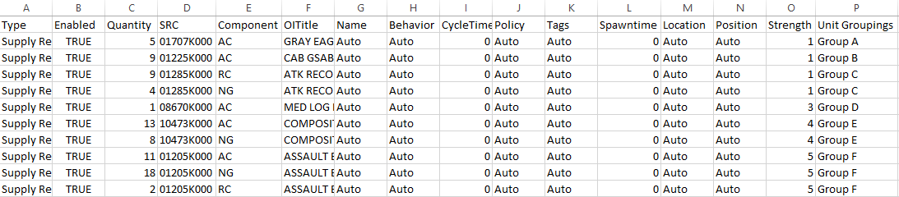

**Demand File**

This file should be the same demand file used to run MARATHON.

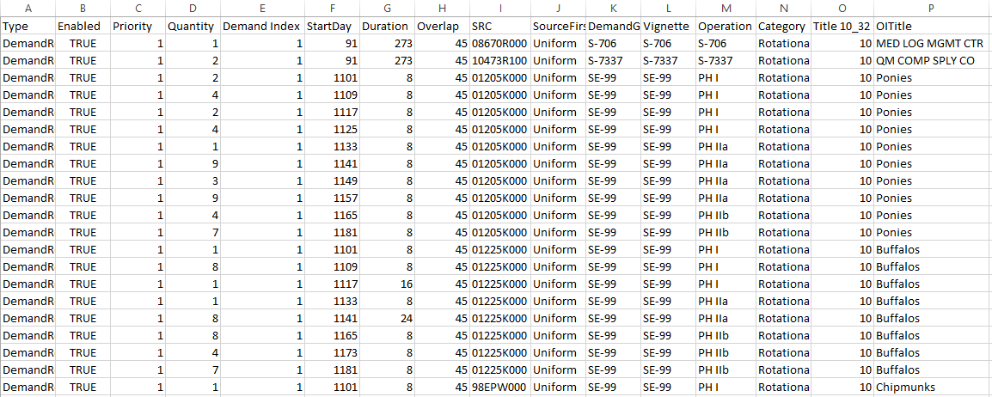

**Cost File**

The cost file has the columns “src” and “total_cost” (case sensitive, in any order), which list the src and corresponding cost.

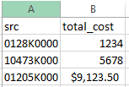

**Requirements File (one for each case)**

This is the output file created from doing a requirement run in MARATHON. This file should look similar to the supply file.

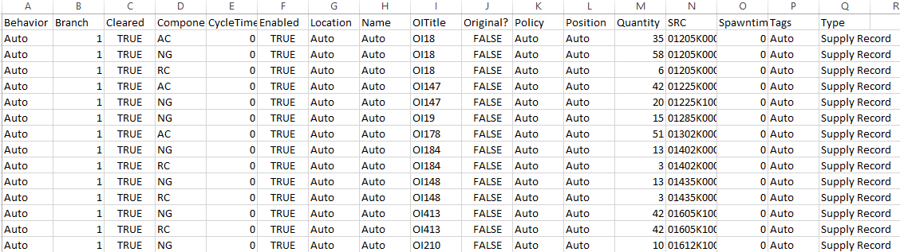

**Input File**

This file is created by the user and should be formatted as a Tab Delimited (.txt) file. The file can have any number of columns listing details about the specific case that is being run, but at a minimum, it must contain the two fields “Case” and “Filepath”.

The “Filepath” field is the path to the requirements file that corresponds to the specific case.



**Running the post processor**

The script is ran by opening the jar file.



For each of the input files, a file select menu will ask the user to locate the input file

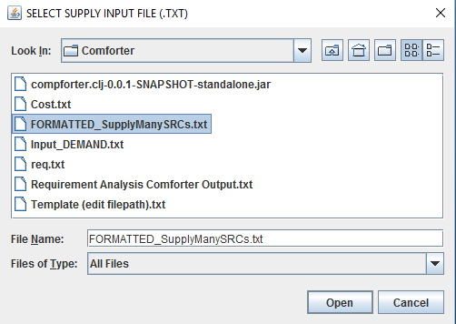

The final menu will ask for the directory for the new file saved to.

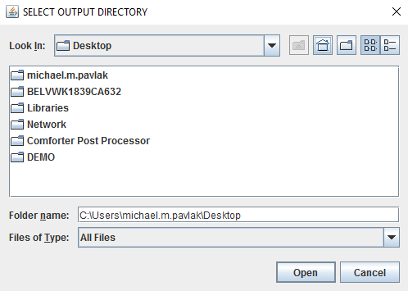

**Output**

If all the inputs are correct a file called “Requirement Analysis Comforter Output.txt” will be created in the selected output directory. If no file is created, there was an error with the inputs. These errors can be seen in detail by running the jar from a terminal or the Clojure environment.

The most likely source of error is a missing/incorrect file path to the requirements file listed in the user created input file.

Example output:

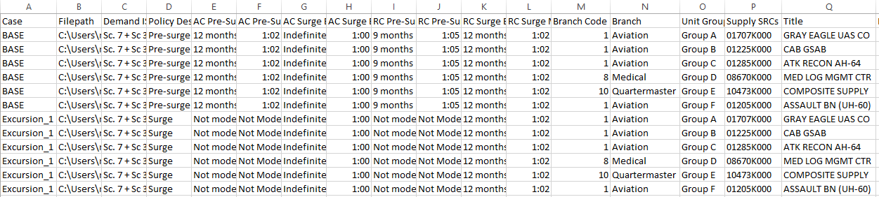

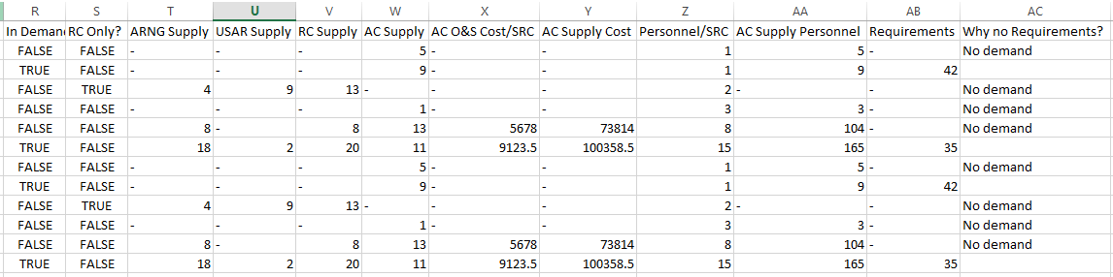

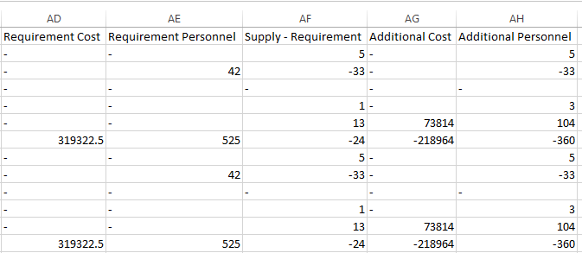

*Excel will try to automatically format the cells using the “general” cell format. The output is already correctly formatted in the .txt file. When importing to Excel, the correct Excel cell format type needs to be selected.